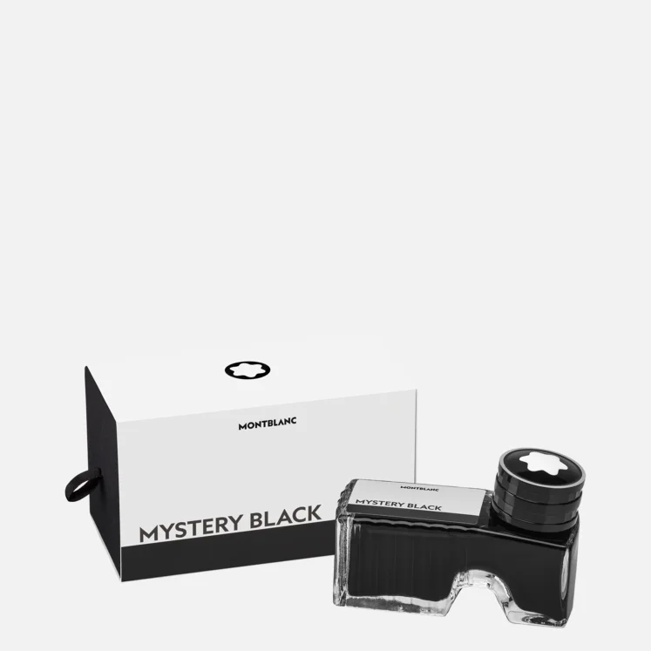

# INK BOTTLE, MYSTERY BLACK

Montblanc Ink bottle 60 ml, Mystery Black. Ink bottle with front compartment for emptying residue into.

The Montblanc Ink Bottle, Mystery Black, is a 60 ml inkwell designed for elegance and convenience. It features a unique front compartment for discarding residue, ensuring a clean refilling process for your fountain pen. The deep, rich black ink provides a classic touch to your writing, perfect for those who value both style and functionality in their writing instruments.